

Competition Administration using Engarde

Sponsored by the Youth Sport Trust


Course Created by Peter Smith & Rodney Francis
Table of Contents
Introduction 4
About the Authors 4
Planning the Competition 5
Timing & Piste Usage 5
Referees 5
Helpers 5
DT 6
Before the Competition 7
Creating a Competition File 7
Acquiring Data for Fencers 8
Entering Fencers 8
Manually 8
From an External Source 11
Starting the Competition 14
Printing a Check-In List 14
Processing Check-In Data 15
Selecting the formula 16
Rounds of Poules 20
Creating the poules 20
Entering Piste Numbers, Times, etc 22
Announcing the poules 23
Adding a fencer to the poules 23
Re-drawing the poules 24
Entering the results of the poules 25
Checking the results of the poules 26
Ranking after the poules 26
Fencing the barrage 27
Promoting all fencers ranked equal 27
Abandoning after the poules but before the DE 28
Printing the ranking after the poules 29
Abandon, scratch or exclude? 29
DIRECT ELIMINATION 30
Creating the tableau for direct elimination 30
Entering Piste Numbers, Times, etc 31
Publishing the DE Draw 33
Printing the DE Score Sheets 34
Receive the DE Score Sheets and Enter Results 34
Alternative Methods of Running the DE 36
The “Single Tableau” Method 36
The “Continuous Fencing” Method 36
The “Leave them to it” Method 37
Which method to use? 38
Publishing Interim Results 38
After the Competition 39
Publishing Final Results 39
At the venue 39
On the internet 39
Creating Results Packs 39
Who needs the results? 39
Advanced Topics 40
Modifying the Language File 40
Modifying the Data Model 40
Creating a Custom Formula 40
What to do when it all goes wrong 40
Restoring a backup 40
Copying the files to another computer 40

Introduction
Engarde is a simple program to use and for the most part its operation is obvious. Generally the program guides you through the correct sequence but as with any reasonably sophisticated process, there are times when there is no substitute for experience.
This course covers all of the routine operations that you will need when using Engarde as well as most of the infrequent ones.
At the end of this course, you should be able to approach organising a competition with confidence.

About the Authors
Between them, the Authors have over 50 years of experience running competitions including County Championships, Region Championships, UK Opens, Winton Cup, Home Internationals, UK School Games, A Grades, Commonwealth Games and World Championships.
They are currently leading the BFA’s program to improve the standard of competition organisation.

Planning the Competition
Before you can run a competition, there are many things that you must consider. Many of these are obvious and outside the scope of this document (venue, budget, marketing, safety, equipment, etc) but some have a direct impact on the way you run the competition so we will look at these in a bit more detail.

Timing & Piste Usage
If you expect your competition to make a profit or to become popular then you need to ensure that you understand your timetable and how you are going to use the available pistes. This is particularly important if (as usual) you don’t have enough pistes to run everything at the same time.
There are many ways of creating a timetable but however you choose to do it, the following times are rough rules of thumb that may help.
 | Foil | Epee | Sabre
Poule of 6 | 1.5 hrs | 1.5 hrs | 1 hr
Poule of 7 | 2 hrs | 2 hrs | 1.5 hrs
DE Match (15 hits) | 20 minutes | 20 minutes | 10 minutes
You should allow at least 30 minutes between the end of the poules and the start of the DE for data processing.
You should allow 30 minutes between tableaux for data processing.

Referees
The number of referees that you can attract will be a big determining factor in how you plan your timetable.

Helpers

DT

Before the Competition

Creating a Competition File
Start Engarde; click on drop-down menu “File”; click on “New competition”.
Select “individual” and click on “ok”. You will then need to complete the following dialogue:
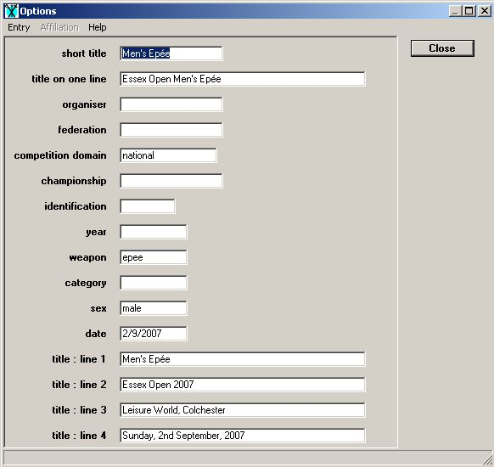
The “short title” will be the default folder name for the competition when you save it. The “title on one line” will appear on various documents throughout the competition. The “title : lines 1 – 4” will also appear on various documents.
In general the items completed in the example are all that are necessary. Make sure that you set the “competition domain” to “national”. This ensures that the default separation in the poules is by Club rather than by Nation.
Once you have completed the necessary items, click on “Close” and you will be presented with a dialogue box to save the competition. The folder will be at one level below the folder in which the Engarde program file is stored.
As soon as this has been done Engarde will immediately open the empty Fencers’ table. There is no need to enter any names at this stage. The next time you open this competition with Engarde, this table will be presented to you.

Acquiring Data for Fencers
The data absolutely required to run a competition are extremely limited. Essential are Name, First name and Club together with each fencer’s current ranking according to the ranking list that is to be used. Other data that is sometimes useful depending on the circumstances are each fencer’s Date of Birth and BFA No. (aka Licence No.).
All except the ranking can be obtained from the entry form because the entry form should have been designed with these requirements in mind. You may have to make enquiries of the competition organiser about the ranking to be used. It may be obvious; senior opens will use the latest ranking at the beginning of the current month but smaller age group competitions may use other ranking lists. Early knowledge of what is required will enable you to make contact with the ranking keeper and enable you to politely ask if they can let you have a copy of what is required as soon as it is available particularly for competitions taking place at the beginning of the month.
It is not necessary to have every detail known when the names are first entered; each entry can be modified later but if you intend to enter the data “en masse” it is better to do it all together.

Entering Fencers
You may enter fencers one at a time or in batches from an external data source.

Manually
When you want to start entering information about fencers into the competition you should start Engarde; click on drop-down menu “File”; click on “Open competition”. Select the competition from the list presented to you and click “Open”. Then click on the file name “competition.egw” and click “Open” again. Engarde will intuitively open the Fencers’ table. To begin entering fencers click on “Input” or to modify a fencer click on “Modify” after selecting the fencer in question. The following dialogue will open:
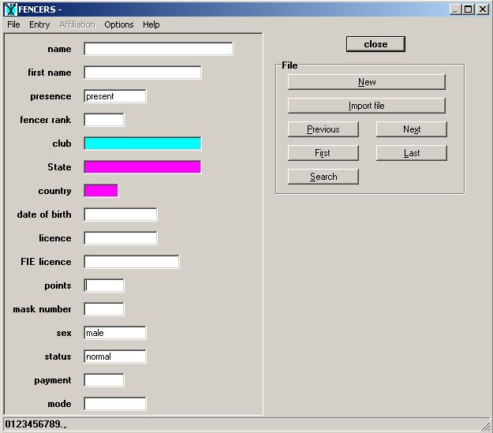
Regardless of the use of the “Shift” key Engarde will always enter the “Name” in upper case and the “First name” in lower case except for the first letter. It is always usual to enter the fencers as “present” since it is easier to mark fencers as “absent” after check-in closes since they will, hopefully, be in the minority. The gender of the fencer is automatically defaulted to that entered in the competition data earlier and all fencers have the status of “normal” until considered otherwise. (The importance of “status” will be explained later in the document.) The “Fencer rank” can be included at this stage if it is available.
The entry of clubs is carried out in a slightly different manner. When the cursor is placed in the “Club” box there is a change to the dialogue box as shown:
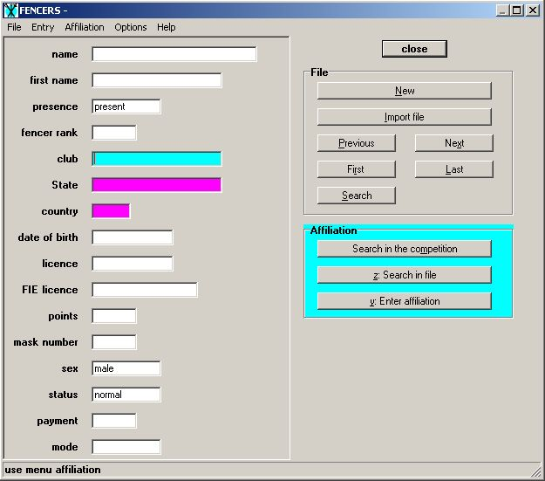
If the club to be entered is not one that has been entered previously in the competition then click on “Enter affiliation” and the following box appears:
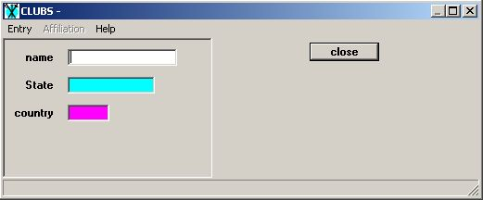
Enter the club name and close the box unless you also want to include “country”. It is rarely necessary to do so for competitions in the UK other than A Grades. In that case the whole entry file is provided by the FIE and so it is still not necessary to use the country dialogue box (which works on exactly the same principle as the club dialogue box).
Once the details for the first individual fencer have been entered click on “New” on the dialogue box and the box changes to that shown above ready for the next entry. Continue entering fencers as necessary. When you come to a fencer with the same club as a previous fencer you should click on “Search in the competition” and the following dialogue will appear:
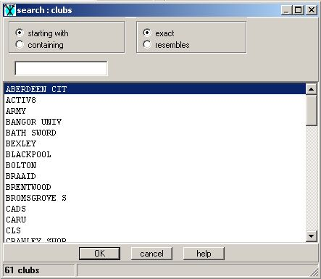
By typing in the first couple of letters you should find the necessary club displayed and then simply double-click it for the name to be transferred to the current fencer. This will ensure that there are not two different spellings of any clubs. If this should occur Engarde will treat them as two different clubs with a consequential failure to separate in the poules. One word of caution. If two fencers of different nationality are given the same club BUT WITH A DIFFERENT NATIONALITY then Engarde will consider them to belong to different affiliations and will not separate attempt them in the poules.
Once all the fencers have been entered the competition file can be closed until further work is required. Additional fencers can be included later, as can further information, if necessary.

From an External Source
If the data for fencers are already available in a spreadsheet or database then the entry can be speeded up considerably. The following is an example of an Excel template that can be used:
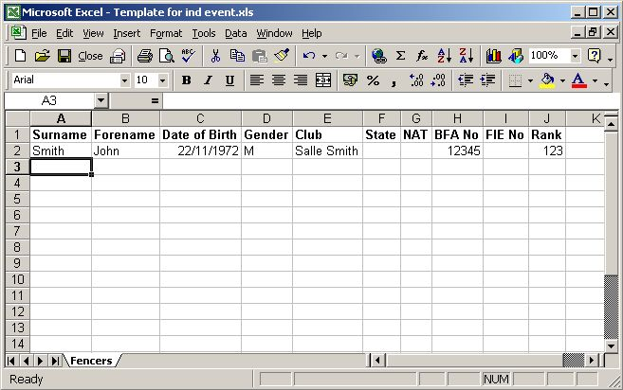
The data need to be cut and pasted in accordance with the column headings as shown. It is not necessary to include data in every column; data can be added later in the Engarde competition file but the more essential data that can be included now then the less that needs to be done later. Once the data are in the correct column order and with fencers starting immediately below the headings you are ready to proceed. There is no need to worry about whether you have used upper or lower case. This will be corrected when the data are imported into Engarde. However it is essential that there are no commas in the data. This sometimes occurs in the club name, e.g. Kings, Canterbury. These commas must be removed.
Select the rectangle containing all the columns and all the rows used. Then click on “File” and choose “Save as”. Choose a directory in which to save the file and then use the drop-down menu “Save as type” to select a .CSV format. Name the file and then save it. Now close Excel without saving.
Open the new file using Notepad or a similar text editor and replace all the commas with semicolons. This can be done very quickly using the “Edit”, “Replace”, “Replace All” facility. Now save the file using the “File”, “Save as” option and give the file the same name but ending in .TXT rather than .CSV. You are now ready to return to Engarde.
Open Engarde and it will again intuitively open the Fencers’ table. Go to the drop down menu “Memory” and select “Load”. In the dialogue box go to the folder containing the file you have just saved. Then go to the drop down menu “Files of type:” and select “FF et Clas (*.fff, *.txt)”. You should now be able to see the file you have just saved so double-click on it. You should see the following:
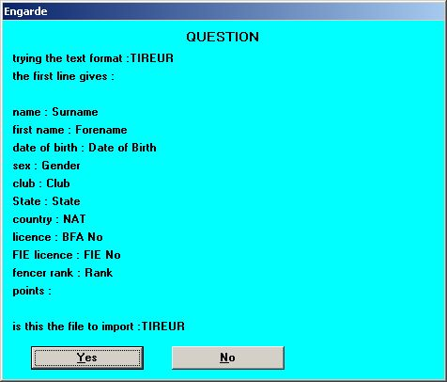
This confirms that the column headings in the original spreadsheet match the requirements of Engarde. Click on “Yes”. Engarde will then ask you to confirm that the first line of the file should be deleted so that the headings are not included as a fencer. Again click on “Yes”. Engarde responds by confirming the number of fencers loaded into memory.
Now go to the drop down menu “Memory” and select “Import all”. Engarde responds by confirming how many fencers are to be loaded into the competition. Click on “Yes” and all the fencers should be loaded into the table. Check the table to ensure that there are no stray data in the wrong column. If this has happened then it will almost certainly have been caused by a stray comma in the original spreadsheet. It should be possible to edit the particular record by moving the data around in the various entries in the dialogue box.

One way or another you should now be ready to start the competition.

Starting the Competition

Printing a Check-In List
Before the competition can begin you obviously need to know how many of those who have entered have actually turned up to the event. For this purpose you must print a check-in list from the Engarde program. It is very important that the check-in list is generated from Engarde so that there is an absolute connection between the check-in list and those late entrants on the day added to it and those who are absent at the end of check-in.
To print the check-in list you need to click on “Report” on the Fencers’ table. You will immediately see a report showing the fencers, probably in alphabetical order, with a large number of fields for each. It is very unlikely that you will want to use all these fields and so you should click on “Contents” which will display the following box:
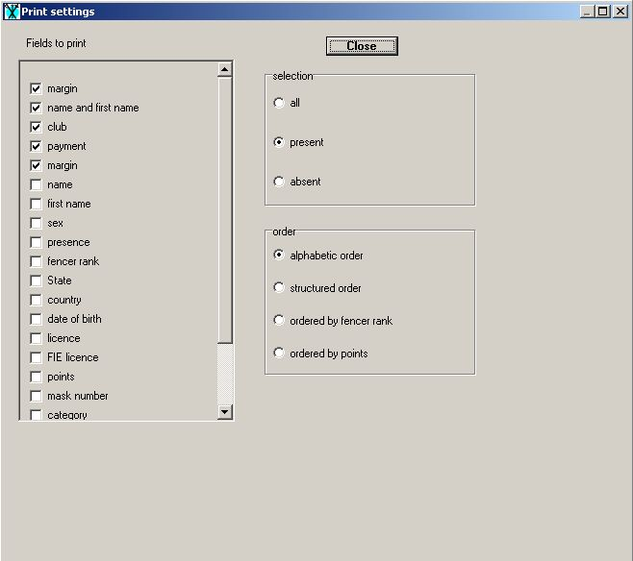
This allows you to choose the fields to display, which fencers to display (all, present or absent) and the order of the fencers. If you are anticipating having to collect entry fees from some of the fencers you can modify details in the fencer file in the normal way and enter the amount due in the box marked payment. You can then include that field in the report as shown above. It is usual to select “present” as the display choice as a matter of habit in case you have marked any fencers as absent beforehand. They will then not appear on the check-in list.
For this report (and all others) you will find that any changes to the fields achieved by clicking on the “Contents” button may not produce the fields in the order that you want them. The solution to this is simply to click and hold on the field heading at the top of the page and drag the field sideways to its required location. Similarly you can change the field widths by clicking and holding the vertical line to the right of the field and dragging to the left to narrow and to the right to widen. This way you can avoid the report being unreadable because a field is the wrong width.
Before printing you can adjust the “Font settings” if you so wish. When you are satisfied with the appearance you can go to “Print”. Since this is a Windows program the printer displayed should be your default printer and unless you need to change this for some reason clicking on “OK” should produce the necessary document to use at check-in.

Processing Check-In Data
Whoever is responsible for checking-in must ensure that the resulting check-in sheet is absolutely clear. All too often confusion can be caused at this point and may lead to a fencer who is present being omitted from the poules or a fencer who is absent being included in them. Checking-in is very important and should be treated as so. Ideally every fencer who checks-in should be highlighted and this should leave visibly untouched all those who are absent and therefore need to be marked as such on the fencers’ table. If the checker-in has been told that a fencer is known not to be coming then it is essential that the fencer’s name is not crossed out. Mark the sheet with the word “scratched” or similar but leave the fencer’s name visible.
It is usual, after check-in has been closed, to announce the names of those who are thought to be absent to give any who are actually present a minute or two to get themselves checked-in. Normally the names would be read from the check-in list but if you have already processed the check-in data you could produce a new report based on the “absent” criteria.
Once you have the completed check-in list you should return to the fencers’ table and mark each fencer who has not been checked-in as absent. This is achieved by selecting the fencer and clicking on the “Absent” button at the top of the page. You should then add in any fencers who have been allowed a late entry at check-in after checking their ranking on the ranking list that you are using. Finally make any changes to the club of any fencer who has asked for a change to be made. It is now strongly recommended that you manually count the fencers on the check-in list who have actually checked-in together with any late entries added. This should be the same number as Engarde shows as present at the bottom of the fencers’ table. If it is not, you will need to reconcile this difference before you move on to the selection of the formula.

Selecting the formula
Click on “Formula” at the top of the main screen to start this selection process. Unless you have a very specific reason for deviating, the correct formula to use is the default one “classic without match for 3rd place”.
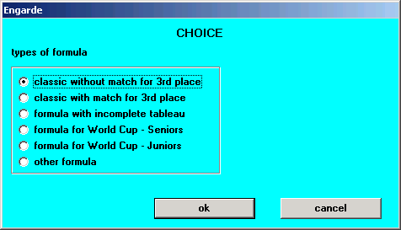
The next prompt will ask you to confirm the number fencers:
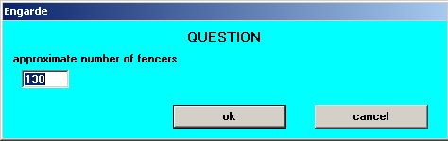
And the next one to confirm the number of rounds of poules:
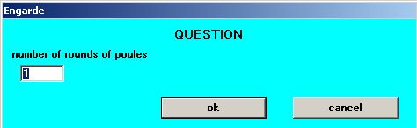
If you make the wrong selection here it is still possible to modify the formula later. You next confirm that the tableaux are to be calculated automatically.
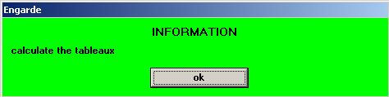
Next you confirm the main options for the competition:
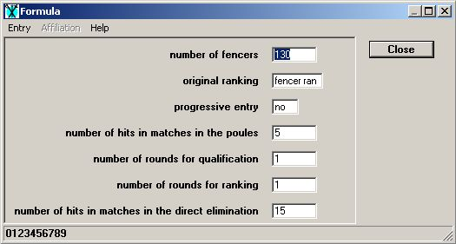
Generally, the only need to deviate from this is if you are running an age group competition in which the number of hits in the direct elimination is to be 10. The next dialogue is actually the main menu for the formula at which point you can modify any of these previously accepted criteria:
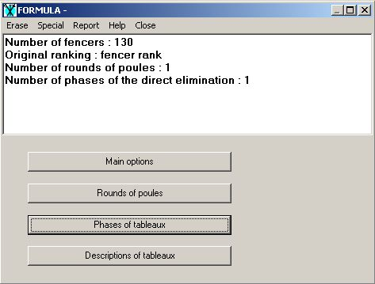
The “Main options” button returns you to the previous screen above this one. However you should review the poules by clicking on the “Rounds of poules” button which takes you here:
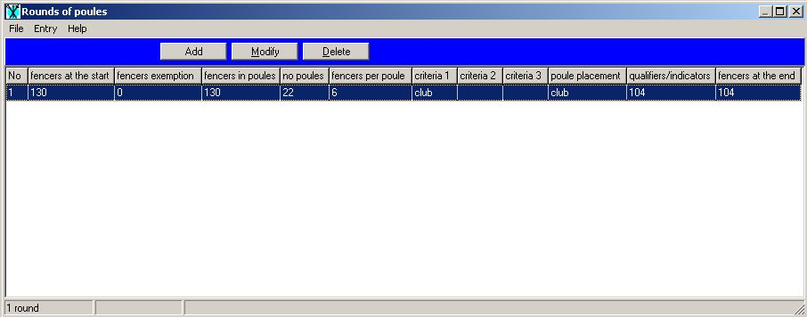
This example shows that round 1 has 130 fencers at the start. No fencers are exempt from the poules and therefore there are 130 fencers in the poules. There will be 22 poules of 5/6 fencers. The fencers will be placed in the poules by clubs and the separation will also be by clubs. There will be 104 fencers promoted to the direct elimination from the poules and, since there were no fencers exempt from the poules, there will be 104 fencers in the competition at the end of the poules.
If you are happy with this then you can simply exit from the box and proceed to the poules. If you wish to change anything then click on “Modify” and you will see this:
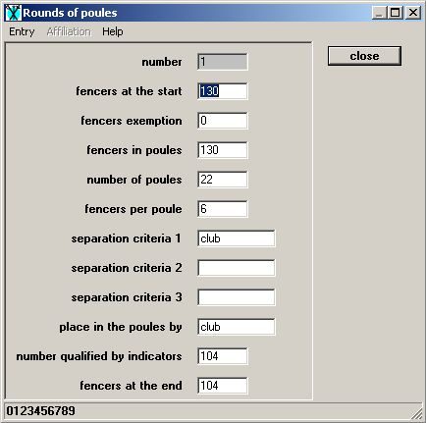
If you wanted to increase the rounds of poules then change the information here so that you have the correct number of fencers promoted to the second round and then after closing this dialogue box “Add” a further round. You can then modify it in the same way to meet your requirements. If you were to add a further round you will need to return to the “Main options” menu to ensure that you have chosen the correct methodology for qualification and ranking into the direct elimination. The usual method is for qualification to be on one round of poules and ranking on two.
Finally exit or close each screen until you are back to the main Engarde screen. You should note that it is very rare indeed that you would need to use the button marked “Descriptions of tableaux” at any stage.

Rounds of Poules

Creating the poules
The next logical step is to create the poules. Click on “Poules” and you will see the following:
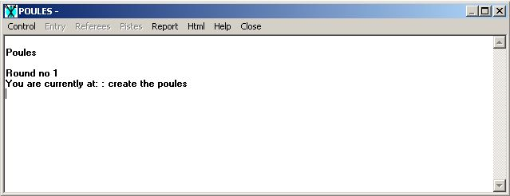
Again the program continues to suggest your next step. To create the poules click on the drop down menu “Control” and select “Create the poules”. You will be asked to confirm your choice of how many poules:
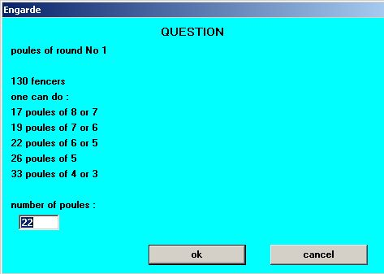
The information provided gives clear information on the implications of any change. You can stick with the original choice or change to something else. Once the choice is made and you have clicked on “ok” you are asked to confirm once more:
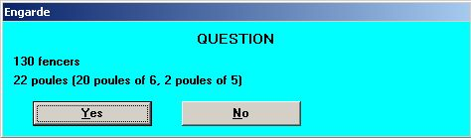
After answering “Yes” you will be asked to confirm your choice of the number of qualifiers:
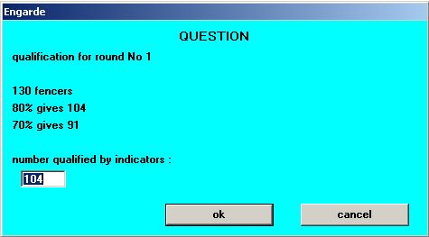
Again information is provided to assist with the decision. After clicking on “ok” the program lets you know if you have perfect separation thus:
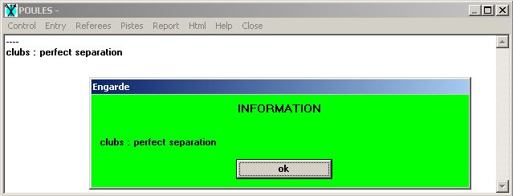
If you have a situation where the separation of clubs does not work properly this will be shown thus:
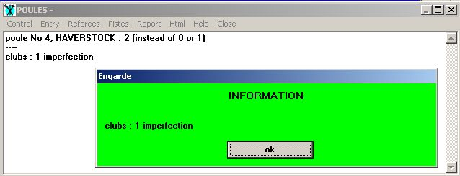
When this happens simply redraw the poules. You do this by clicking on the drop down menu “Control” and selecting “Redo the poules”. Engarde will randomize the equal (999) seeds in a different way each time so eventually you will get a good separation. It is rare for this to need more than four attempts.
In the event that you believe you cannot get a good separation, it is suggested that you examine the seedings before resorting to manual modification of the poules. This situation can only really happen if you do not have at least (2 x number of poules) fencers seeded at the lowest level. If this is the case, consider increasing the number of fencers with the lowest rank (either 999, blank or any other high value). Then try “Redoing the poules” again.

Entering Piste Numbers, Times, etc
However, before that you need to enter the details of the piste number for each poule. This is achieved by clicking on the drop-down menu “Pistes” and selecting “Pistes”. When you enter “1” in the box for “Poule no” and click on “Load” you will see the following:
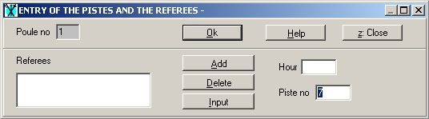
Enter the required piste number and hit “Enter” twice. You should now be in the correct box to enter the next piste number. Continue until all piste numbers have been entered. If you do not have enough pistes to run all the poules at this time simply leave the box blank for the delayed poules at this stage.

Announcing the poules
Historically, this has meant using such PA system as might be available or simply shouting out as loudly as possible to tell everyone the names of the fencers in each poule and which piste the poule is on. This is now generally accepted to be a waste of effort. Many PA systems are very poor and organisers’ voices very quickly get worn out. Much the most efficient method is to print a report from the poules’ menu.
Now click on the drop down menu “Report” and select “Fencers, Poules, Pistes”. Check that the column widths are correct so that everything can be read and then print the report a couple of times so that you can pin them up in two different locations. Then you can announce that fencers should check where they are fencing and go straight to their pistes. It also gives anybody not on the list the opportunity to shout before the poules are distributed and this can make a re-draw less painful.
Whilst this is happening you can go the report “Poule sheets” and print them. Before doing so it is very important to check the column widths in this report because the fencers’ numbers between the fencers and the grid are invariably missing when you first view the report. Their absence may make completion of the sheet on the piste more prone to error. The sheets can then be put on to the clipboards and distributed.

Adding a fencer to the poules
There’s always somebody who arrives late and begs to be let in. If you are feeling particularly generous and you do not have exactly even poules then the procedure is:
- Open the fencers’ table and mark the latecomer as “Present”.
- Examine the poules into which the fencer can be fitted (if there is more than one). In selecting the poule, try to respect the separation of clubs & seeding if at all possible but if it is not possible then don’t worry. Normally, higher ranked fencers tend to arrive in plenty of time so the only person really disadvantaged is the late fencer himself.
- Click on the drop down menu “Control” in the Poules menu and select “Modify the poules”. Enter the appropriate poule number in the first box and click on “Load”. You will see the following dialogue box and you will be asked to confirm that you wish to modify it:
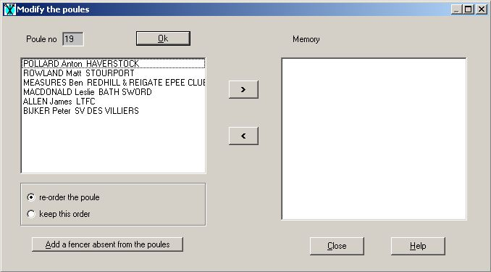
- Click on “Add a fencer absent from the poules” and double-click the fencer from the list. The fencer will be placed at the bottom of the list. Now change the order requirement from “re-order the poule” to “keep this order” and click on “Close”. You will see a repeat of the confirmation or otherwise that you have perfect separation.
- Examine the formula to ensure that the correct numbers of fencers are promoted.
- Print the new poule sheet and ensure that the fencers already in the poule transfer the results of any fights already completed are transferred to the new poule sheet before continuing in the order of the new poule sheet.

Re-drawing the poules
The rules are silent on this but the practice at FIE level is clear. Once fencing has started, the poules will not get re-drawn to correct a mistake no matter who made the mistake.
If you decide that the mistake is so bad as to warrant a re-draw, this is your right but in general terms it should not even be entertained if any poule has completed a fight.
If somebody notices late that they have been left out of the poules due to a mistake by the DT then they should be added to a suitable poule wherever possible in the same way as the latecomer described above.

Entering the results of the poules
To enter the results of the poules you should click on the drop down menu “Entry” and select “Enter the poules”. Type the relevant poule number into the box and click on “Load”. You will open the following dialogue box:
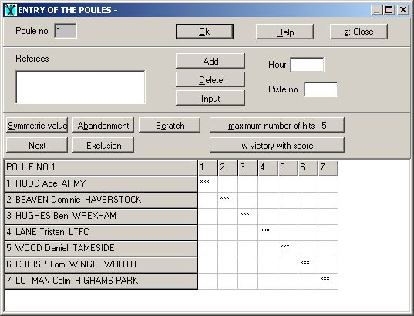
Confirm that you have selected the correct poule by comparing fencer number 1 on both box and sheet. Then enter the scores into the grid just as they appear across the sheet. Only one key press is necessary to move to the next empty square for scores of “0” to “4” and “V”. The one exception to this is if there has been a victory with less than 5 hits. In this case enter “W” and then enter the number of hits. On the entry sheet this will translate into “V4”, etc. To reduce the chances of error to an absolute minimum always compare the vertical scores on the sheet with the vertical scores on the screen.
Whilst entering the results you may find that you get the following, or a variation on it, to tell you that there is an error on the scores:
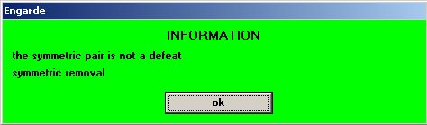
If this should occur you should first check that you have transferred the data correctly from the sheet. Assuming that you have entered the data correctly you may be able to check the result from the fight matches at the bottom of the poule sheet if the results have been entered there by the referee(s). Otherwise it will be necessary to call the fencers to the DT. Before doing so complete as much of the grid as possible because the error may be due to a transposition of the results on the poule sheet that requires you to call more than just two fencers.
Once the fencers have been called it is possible to move on to the next sheet by clicking on “OK”. Engarde will confirm that the poule is incomplete but will save the data thus far entered and allow you to enter data for the next poule whilst you wait.
If, for any reason, a fencer has not completed all their fights in a poule then none of their results are to be included. In this case place the cursor in the first square of the grid opposite their name and enter “A”. This will fill their entire row with “A”s and the symmetric pairs are filled with “X”s. You can then complete the other scores around these entries.

Checking the results of the poules
As soon as all the poule results have been entered and in order to reduce the likelihood of problems later, it is good practice to print and display copies of the complete results of poules and ask the fencers to check them. This gives everyone the opportunity to correct errors that have been made either on the poule sheets themselves or during the entry process into the program. Printing can be carried out by clicking on “Report” and selecting “Poules”. Check the column widths and adjust as necessary before printing to ensure that everything is properly visible.
If there are any complaints then first of all retrieve the relevant poule sheet to see whether the error is in the entering of the data. If so, then a simple correction can be made. If not, then it will be necessary to get both fencers together to resolve the issue. If they cannot agree, then the result should be allowed to stand but this is a rare occurrence.

Ranking after the poules
Engarde now reminds you that you have reached the stage of ranking after the poules. This is carried out simply by clicking on “Control” and selecting “Ranking”. Normally Engarde will simply tell you that the poules have now been completed. However, occasionally there will be a problem in that Engarde will display the following:
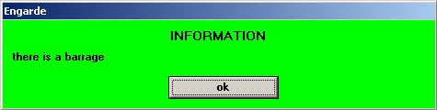
When you click on “OK” you will see something similar to the following:
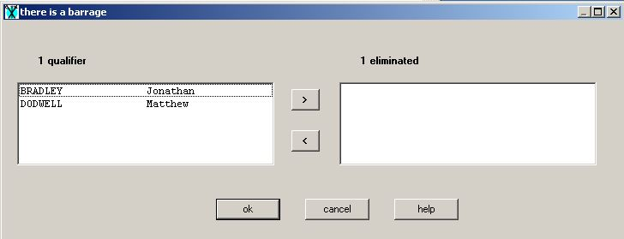
You now have two choices. You can either arrange for the barrage(s) to be fought or you can increase the number of fencers promoted so that all those who are equal for the last place(s) are included in the direct elimination. Either way you need to make a note of the numbers of fencers involved (how many qualifiers and how many eliminated) and their names.

Fencing the barrage
Regrettably Engarde does not provide match sheets for a barrage so you will have to improvise with blank paper. If there are only two fencers involved then a single fight must take place to five hits and the result is then known.
However if there are more than two fencers involved you will need to have as many fights as are necessary for them to each fence one another. Afterwards you will need to calculate their ranking in their mini-poule. You can then use the box shown above to move those fencers who are to be eliminated into the right-hand box and then click “OK”. That completes the ranking after the pools.

Promoting all fencers ranked equal
If you have decided to do this then you need to calculate the changes you need to make to the formula. From the box shown above you can see that in this example 1 fencer is to be eliminated. This figure may vary from competition to competition.
You need to close the Poules menu and open the Formula menu. Click on “Rounds of poules” and then on “Modify”. Now increase the “number qualified by indicators” and “fencers at the end” by the number of fencers who should have been eliminated. Close the Formula menu and return to the Poules menu. If you have done this correctly the ranking should now work completely. The poules are now completed.

Abandoning after the poules but before the DE
This situation arises when a fencer tells you they want to abandon after completing their poule fights but before the start of the direct elimination. The rules are not very clear on the subject and the practice in Opens is rather different to FIE A Grades. The problem arises because what you do next can considerably affect the fencer’s final ranking.
If they abandon at the end of the poules then Engarde will place them last in the overall ranking. If they allow their name to go forward into the direct elimination stage and they then go to their piste and tell their opponent and the referee that they are abandoning at that time then Engarde will award the fight to their opponent. Their place in the overall ranking will be no different from the situation in which they have simply lost the fight.
It is only right and fair that you should explain this to the fencer and let them decide. If you have already drawn the first round of the DE stage then it is suggested that you proceed on the latter basis in any case.
If you are going to exclude the fencer from the DE then the following actions are necessary:
- Open the Fencers menu and select the fencer. Click on Modify and, in the “status” box type an “a”. This will appear as “abandonment”. Close and exit the Fencers menu.
- Draw the DE (described in more detail below). The fencer will be removed from consideration and everyone below him will move up a place in the tableau.
- The fencer will be placed last in the ranking.
If the fencer is included then:
- Draw the DE (described in more detail below) or let the draw stand if this has already been carried out. Advise the fencer’s opponent that he has a bye. Strictly according to the rules, the fencer must present himself to the referee on the piste and withdraw at that point but there’s no need to actually do this.
- Enter the result of the fight, selecting the “Abandonment” option for the fencer.
- The abandoning fencer retains his tableau seeding in the final ranking.

Printing the ranking after the poules
Before leaving the topic of poules you must remember to print a couple of copies of the full ranking after the poules giving details for each fencer including their indicators and whether they are a “qualifier” or have been “eliminated”. These should be pinned up for the benefit of fencers.

Abandon, scratch or exclude?
This is an appropriate time to draw your attention to the significant differences between “Abandon”, “Scratch” and “Exclude. So far as the poules are concerned these three all have the same effect on a fencer, i.e. that the fencer’s results are totally removed from the competition and the fencer is placed last in the overall ranking.
However the situation changes once the direct elimination stage has been started. As explained above, when a fencer is unable, for one reason or another, to start or continue a fight then they abandon. When the result sheet is returned to you the fencer’s score is set to abandon and they lose the fight but retain the relevant position in the final ranking.
If a fencer fails to present himself at the piste when required to do so (with all the safeguards of an appropriate number of calls), then he is considered to be scratched. His score is set to scratch and not only does his opponent win the fight but the fencer
If a fencer has a black card awarded against him, then he is excluded from the competition. His score is set to excluded and his opponent wins the fight. Again the fencer is excluded from the overall ranking. In this case also the other fencers do not move up a rank. The fencer will also be liable to suffer any appropriate penalties imposed by the governing body.Direct Elimination

DIRECT ELIMINATION

Creating the tableau for direct elimination
Open the Tableaux menu, click on the drop down menu “Control” and select “Creation of the tableau”. Engarde asks for confirmation of the number of fencers and thus the size of the first tableau. This will almost always be correct and you should just click on “Yes”.
However, if this is not correct you will need to click on “No” and then review the formula you are using. If you make any changes, you will also need to return to the Poules menu so that you can redo the ranking with the new conditions. In the Poules menu click on “Control” and then select “Go back to the previous round”. You will be asked to confirm this step:
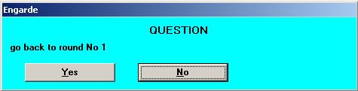
Click on “Yes” and you are back to being ready to carry out the ranking. Proceed as previously.
Return to the Tableaux menu, click on the drop down menu “Control” and select “Creation of the tableau”. Engarde again asks for confirmation of the number of fencers and thus the size of the first tableau. This time you should be able to just click on “Yes”.
Engarde will now confirm which tableau you have got to and lists the match reference numbers of the DE fights that have to be printed and have to be entered:
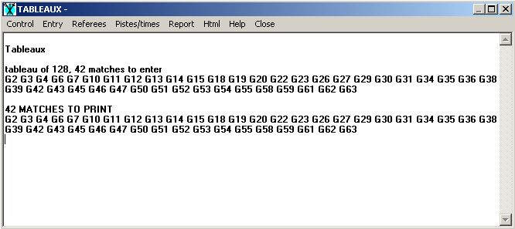
As soon as you have printed the relevant sheets it will simply display the matches to be entered.

Entering Piste Numbers, Times, etc
In order to manage the fencers successfully it is really essential that you ensure that the piste numbers are included on both the published tableau and on the match sheets. In some circumstances this can be added to the relevant paperwork after it has been printed but it is much safer to enter the piste numbers into Engarde to avoid any discrepancies between the two.
Engarde has two facilities for entering piste numbers. One is far quicker than the other but is also far less able to deal with a number pistes which is not a power of 2, i.e. not 4, 8 or 16, etc. If you are able to use a suitable number of pistes then click on the drop down menu “Pistes/times” and select “Enter pistes and times of a tableau”. Select the relevant tableau and you will see something similar to the following dialogue box:
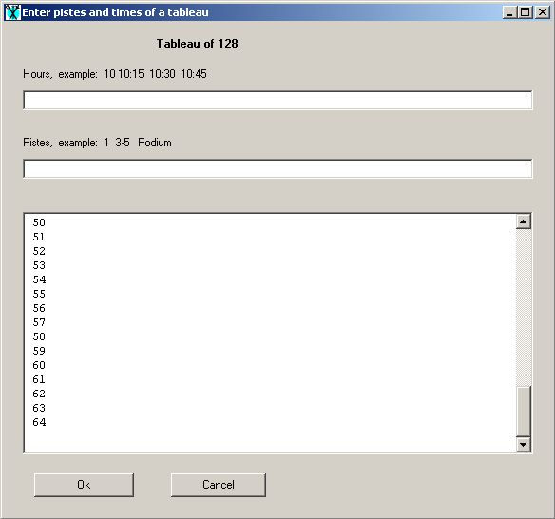
In the box beneath the words “Pistes, example: 1 3-5 Podium” enter the numbers of the pistes to be used. Engarde will allocate a piste to every match spreading them evenly amongst the available pistes. Even if a tableau is incomplete every fight number will have a piste number but there should be a similar number of fights allocated to each piste for the fights that are actually to take place.
If the number of pistes to be used is not a power of 2 then it is better to allocate the pistes using the alternative method. Click on the drop down menu “Pistes/times” and select “Enter pistes”. Ignore the fact that there is no match at fight “g1” (in the example above) and enter “g1” into the Match no box. You will see something similar to the following:
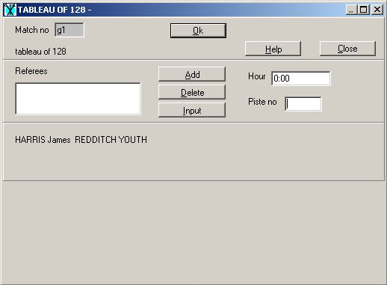
Divide the number of fights in the complete tableau (even if it isn’t) by the number of pistes to be used. For example, if there are 64 fights and you are using 12 pistes then you will have 5 fights on each piste but allocating the remaining 4 fights will actually mean that there will be 4 pistes with 6 fights on. Enter the first piste number and hit “Enter” twice. You should now be in the correct box to enter the next piste number. You will need to enter the first piste number into 6 different boxes. The do the same for the second, third and fourth pistes. After that you only need to enter the piste number 5 times before moving on to the next, and so on until each match in the tableau has a piste allocated to it. As with the previous method, even if a tableau is incomplete every fight number will have a piste number but there should be a similar number of fights allocated to each piste for the fights that are actually to take place.

Publishing the DE Draw
Print the draw by clicking on “Report” and selecting “Tableaux and pistes”. Invariably it will be necessary to tidy up the column widths so that the fencers have a clear view of the information they need.
Before publishing the draw check through the tableau to see if there are any pistes with totally the wrong number of actual fights to take place. If there are, it will only be a small number and these can be changed by hand whilst ensuring that the match sheets for any fights moved are also updated.
You are now in a position to pin up the tableau (preferably in two different places) and ask the fencers to check where they are fencing and go directly to the piste

Printing the DE Score Sheets
Print the match sheets by clicking on “Report” and selecting “Match sheets waiting”. Then confirm the selection. Your choice of how the matches should be printed will depend on how you intend to cut the sheets into individual matches:
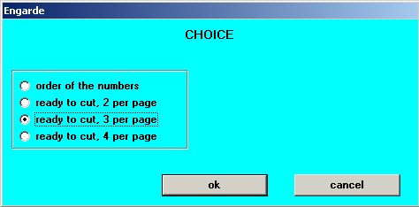
If you are going to cut the sheets one at a time then select “order of the numbers”. If you have access to a method of cutting several sheets at once then select “ready to cut, 3 per page”. With an incomplete tableau only those matches which actually have to take place will be printed even though the tableau as printed shows a piste even if there is no match to take place.
Remove the “signature” boxes (since they are no longer required) by clicking on “Contents” and unselecting it. Then adjust the remaining column widths before printing the sheets. They can now be attached to the clipboards and distributed after making any adjustments as described under the second paragraph of “Publishing the DE Draw” above.

Receive the DE Score Sheets and Enter Results
Once you start to receive completed match sheets you should click on “Entry” and then select “Entry of the matches”. Type the match number from the match sheet into the box and click on “Load”:
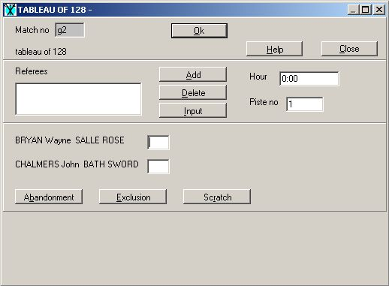
Enter the first fencer’s score and then Tab to the second box to enter the second fencer’s score. Now hit Enter and you will be asked to confirm the winner:
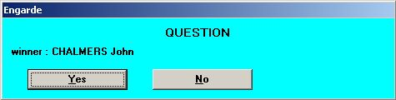
This should tally with the name in the Winner’s box. If so, click on “Yes” and proceed to the next result. Otherwise click on “No” and you will be returned to the entry dialogue. Click on “Close” in order to seek clarification from the referee and/or fencers concerned. Meanwhile you can continue with the entry of other results.
As you enter results from one tableau you will see the number matches to be entered and to be printed from the subsequent tableau increases in the Tableaux box:
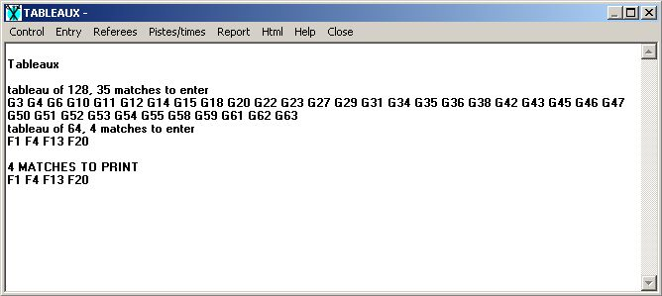
Once all the results from a tableau have been entered you are in a position to print the match sheets for the next tableau.

Alternative Methods of Running the DE
There are several methods of running a DE tableau and the one you chose will depend on your own preference, the number of helpers you have, the referees available and the number of pistes.
In each method, the key to success is making sure that you understand how the competition is progressing and ensure that you maintain control of the timetable. Your helpers are vital to this task.

The “Single Tableau” Method
This is the most natural and easy to understand method and is the one described in detail above. You send out all of the matches for a tableau at the same time and do not start any matches in the next tableau until all the results for the current stage have been returned.
The advantage of this method is that it is easy to understand what stage you have reached in the tableau and how much longer it will take to complete.
The big disadvantage of this method is that a problematic piste can cause serious delays to the entire event and make you appear disorganised as a large part of the venue will be empty! To compound this problem, the most likely stage for this to occur is when you have 4 fights on each piste – normally the tableaux of 128 and 64 – and this can make it difficult to recover the time later on.

The “Continuous Fencing” Method
This method varies from the “Single Tableau” method in that instead of waiting for a tableau to complete before printing and issuing the next batch of matches, you do so as soon as the match is available.
You can only use this method if you have organised the competition to ensure that:
- a fencer’s match in the next tableau is on the same piste as his previous one;
- the winning fencers have been instructed to remain by the piste on completion of each match;
- if you have referees, they have been briefed to return each match sheet individually, as soon as it is complete.
This method can allow the competition to run without any breaks for processing but the big disadvantage that it has is the feeling of chaos. It is normal to have matches taking place simultaneously in 2 or 3 different tableaux and this can be confusing for both the organisers and the fencers.
It is also extremely hard on referees if, as would normally be the case, you have a single referee allocated to each piste.

The “Leave them to it” Method
This method involves printing a section of the tableau and issuing it to the fencers along with a supply of blank match sheets. The fencers then continue fencing off the winners until a single victor emerges from their section of the tableau.
Engarde is not very well suited to this approach as to enter each match you must know its match number and there is no standard report that includes this information so a degree of manual work must be done in preparation. You must also have a stock of blank match sheets as Engarde does not allow these to be printed.
Other disadvantages of this method are:
- It is very easy for you to lose track of the competition. This method produces the longest gap between issuing the paperwork and receiving it back and if something goes wrong you are unlikely to know about it until the competition is already seriously delayed.
- At the end of each section, there is a large volume of data entry to bring Engarde up to date. For example, if you have issued the tableau of 64 on 8 pistes, you end up with 7 results per piste all at approximately the same time.
- In order to make is work, you either need to have the fencers refereeing themselves or allocate more than one referee per piste. This is often not possible even at the best supported competitions.

Which method to use?
There is no real way of telling you which is the best method to use in any given situation. You may end up with a mixture of all of them or another scheme of your own creation. It is really up to you to determine how best to use the staff and pistes that you have available.
For the GB Nationals, we generally use a hybrid of the “Single Tableau” and “Continuous Fencing” methods. It is very efficient to issue an incomplete tableau of 128 at the same time as the initial fights for the tableau of 64 and then complete the tableau of 64 as the initial results are returned.

Publishing Interim Results

After the Competition

Publishing Final Results

At the venue

On the internet

Creating Results Packs

Who needs the results?

Advanced Topics

Modifying the Language File

Modifying the Data Model

Creating a Custom Formula

What to do when it all goes wrong
ABOVE ALL, DONT PANIC!

Restoring a backup

Copying the files to another computer

